**Irakli Lomidze - G00275525**

Mobile Application Project

Research

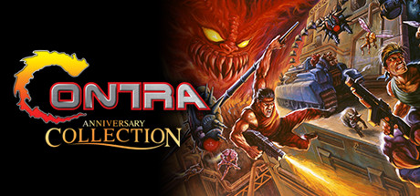

A Classic Horizontal example of a 2d shooter game would be Contra. Contra is a video game series produced by Konami composed primarily of run and gun-style shooting games. The series debuted in 1987 as a coin-operated arcade game titled Contra, which was followed by the release of Super Contra in 1988 and several sequels produced for various home platforms.

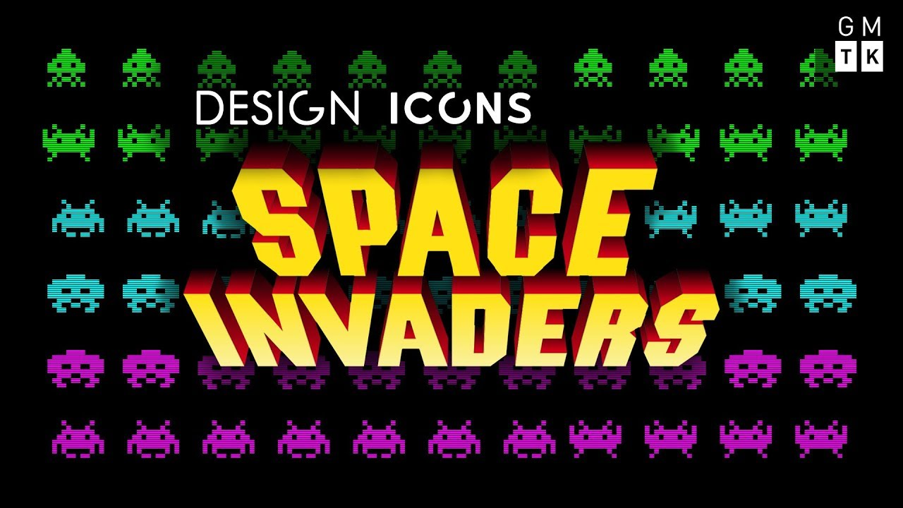

Space Invaders is an Vertical arcade game which was created by Tomohiro Nishikado Space invaders is an example of a Top-Down shooter game. It was one of the first ever fixed shooter game. The aim of the game is to defeat waves of aliens that are descending and shooting at you. The game was also well known due to the music they used.

**Game Overview**

I chose horizontal for my game. This game is going to be a mixture of both Space Invaders and Asteroids. The game is a shooter game using Unity's 2D physics. The main concept of the game is to move a spaceship or character in space while fighting other ships or enemies while also avoiding and shooting asteroids.

**Objectives**

The title of the game is Space Shooters and the genre of the game is 2D Shooter. The player will be able to control the game with the up, down, right and left keys on the keyboard. The player will have to move the Spaceship and destroy the enemies as they proceed through the game. The main idea is that there will be Enemies that the player will face, and he must kill them in order to advance to the next level.

The Game will be created using Unity and is for people who enjoy simple games that are enjoyable to play.

The Battleships objective is to defeat the enemy ships and pass as many levels as possible in order to beat the game.

• Difficulty

Difficulties in my game increases throughout my levels, from level 1 to 3 enemies are harder to destroy and they movement is faster.

• Enemies

Enemy ships, who can attack by shooting lasers at the Battleship or player.

• Background

For my Background I decided to go with a purple space background filled with stars. This is to represent space in real life.

**Front End**

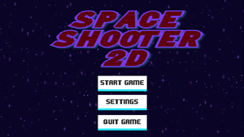

This is an example of how the home screen will look like. There will be three option, Play, Settings and Quit.

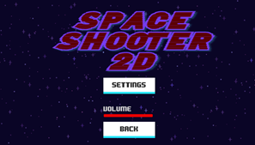

The Settings button will allow the player to change the increase and decrease volume of the game. There will also be an option to go back to manu.

The Quit option will allow the player to quit the game and exit the menu.

Control Mechanisms



I chose to go with these controls because they are some of the easiest controls to remember and are very common so new players will be familiar with these controls.

The Game

The game will start with the battleship standing and the user will move it with the arrow keys. The user will get a couple of seconds to get used to the controls and then the enemy ships will come out and start shooting at the player. The Battleship must then protect itself by moving and avoiding the lasers and shoot back to kill the enemies. There also asteroids that the player must avoid and shoot. The Asteroids can also protect the player from enemy fire. player has 3 respawn life’s If the player is hit 3 times it will be destroyed and one life will be taken away, if all 3 lifes Is used the game is over. The game can also be paused. When the game is paused the user can resume the game,go back to main menu, quit the game or change game sound volume.

The main objective of the game is to kill the enemy ships and progress through the levels and difficulties.

**Characters**

|  |  |  |
| --- | --- | --- |
| Character | Description | Powers |
| Battleship | The battleship’s goal is to protect the galaxy from all evil. | The battleship is controlled by the Player and can shoot deadly lasers to destroy its enemies. |

|  |  |  |
| --- | --- | --- |
| Character | Description | Powers |
| Enemy Ship | The enemy ship wants to destroy all life and take over the galaxies. | The enemy ship can duplicate and is powerful enough to kill the battleship. |

**Gameplay Guidelines**

The guidelines for this game are very simple that the player try to kill as many enemy’s as possible and complete the game. The players will earn high score after passing each level after completing game they will be rewarded game high score which they can try and beat after starting new game.

**Difficulty**

The game will include levels which the player must pass to get to the next level. The levels will be based on the Level difficulty, levels get harder after each level.

**How I would improve game in future**

I would like to add level where Player would face off against Boss character where final level would take place. I would also like to try user to choose different characters to play with. I would also like this game to run IOS and Android.

**Game Assets**

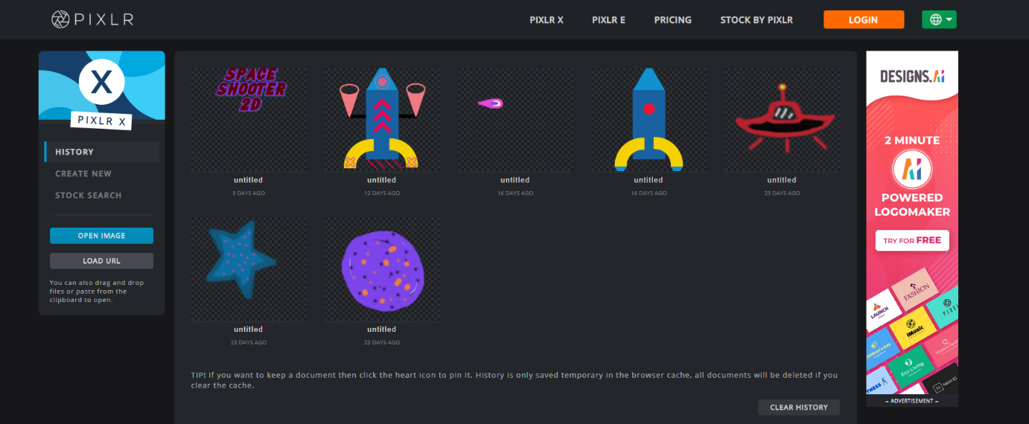

I created almost all the game assets, I use player spaceship shit, asteroid, and damage animation from internet.

**Referances**

LearnOnline - <https://learnonline.gmit.ie/?redirect=0>

YouTube - <https://www.youtube.com/>

Movement - <https://www.youtube.com/watch?v=whzomFgjT50&t=975s>

Scrolling Background - <https://www.youtube.com/watch?v=H6q-Y5JAiDk>

Shooting - <https://www.youtube.com/watch?v=LNLVOjbrQj4>

Sound - <https://www.youtube.com/watch?v=6OT43pvUyfY>

Pause menu - <https://www.youtube.com/watch?v=JivuXdrIHK0&t=348s>

Settings menu - <https://www.youtube.com/watch?v=YOaYQrN1oYQ&t=908s>

High menu - <https://www.youtube.com/watch?v=vZU51tbgMXk>

Game Music - <https://freesound.org/people/rezyma/sounds/475148/> , <https://freesound.org/people/Volvion/sounds/315717/> , <https://freesound.org/people/HenryRichard/sounds/448266/> , <https://freesound.org/people/myfox14/sounds/382310/> , <https://freesound.org/people/tyops/sounds/423805/>

Photo shop - <https://pixlr.com/>

For some of the assets - <https://www.kenney.nl/assets>

Adobe photoshop

Form my game I didn’t copy and paste any code that I have referenced I simply took them as lessons and for better understanding of how to built game in Unity.